### **INSTA.id presents D.E.V.s.**

### **D**igital **E**mployment **V**erification **s**ystem

### **Description**

InstaId.xyz is a digital identification app that allows your clients/customers verify your employees while they are in the field. The application’s interface is split into two the employee web-app and the administrator dashboard.

From the Administrator’s Dashboard admins can manage employees (basic CRUD functions) and update their current employment status.

[dashboard gif here]

From the responsive web-application employees can login and generate an exclusive QR Code based for your client/customer to scan.

[employee app gif]

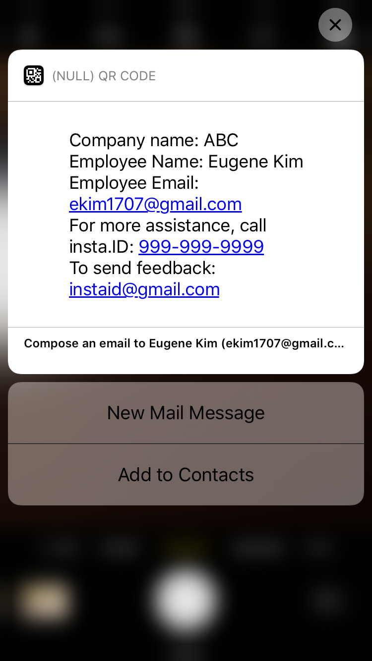

### **How to deploy Insta.id**

Step 1: Clone repo

[screenshot]

Step 2: From the directory you just cloned, install dependencies:

npm install

Step 3: Create a “.evn” file:

File defaults are the following:

DB_HOST=localhost

DB_PORT=5432

DB_NAME=identifydb

Step 4: Install postgres if not already installed

[**https://www.postgresql.org/download/**](https://www.postgresql.org/download/)

Step 4a: To build the required tables:

**npm run db:reset**

Step 5: Browse to localhost:3000 (this is a default setting).

[screenshot]

### **Technologies Utilized**

* Node.js
* Node.js primary dependencies:
  + Qrcode: <https://www.npmjs.com/package/qrcode>
  + Base64-img-promise: <https://www.npmjs.com/package/base64-img-promise>
  + Sweet Alert 2:
  + Pg-promise:
* Postgres Database
* Express.js
  + ejs - Templating language
* JavaScript
  + jQuery
* CSS
  + Bootstrap
* HTML

## **Contributors**

* Eugene Kim: https://github.com/[ekim1707](https://github.com/ekim1707)
* Tracy Nguyen: https://github.com/nguyentracy
* Jonathan Alicea: <https://github.com/jfalicea>

*Special Thank Yous to the DigitalCrafts Team:*

* Rob Bunch: <https://github.com/rbunch-dc>
* Jonathan Ray: <https://github.com/ray-jonathan>
* Tony DiRusso: <https://github.com/A-DiRusso>
* Chris Aquino: <https://github.com/radishmouse>